Elita Lestari Setianto (201344008) | Rangkuman Minggu 5 | Selasa, 27 September 2022
Elita Lestari Setianto (201344008) | Rangkuman Minggu 5 | 16TNK5043 (Aplikasi Mikrokontroler)
3NK | Rangkuman Minggu 5 | Ferry Satria, BSEE.,M.T.  Rahmawati Hasanah,S.ST.,M.T.

Mengenable semua pake SEI Mengdisable semua pake CLI

Klo mau membuat int 1 pake bit 7
Int 0 bit 6
Int 2 bit 5

Enable 0 pake logic 1 (GICR)
Misal int 1 mau di enable jadi 10000000 LDI R20, 0X80
Out gicr,r20

Klo mau int1 jadi rising edge (MCUCR) LDI R20, 0X0C
OUT MCUCR,R20
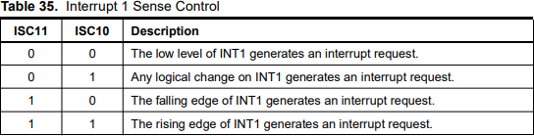

Klo mau int 0 jadi low level LDI R20,0
OUT MCUCR,R20

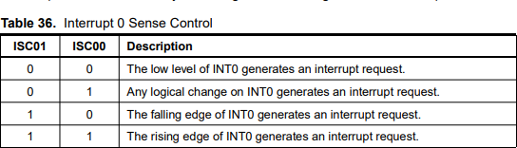

INTERRUPT VEKTOR INT 0 : 001
INT 1 : 010
INT 2 : 011

Perintah untuk mengakhiri interrupt
Klo ada 8 7 segmen harus menghubungkan semua jadi Satu
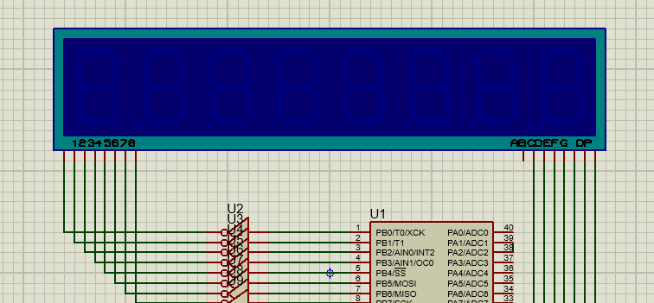
12345678 :
ABCDEFG : common

Program menampilkan huruf Rajin
;Program Interrupt dan Timer
; pakai project "ROOT"
.include "m8535def.inc"
.org 0x00
.equ timer_1=0xFFF0 rjmp main

.org 0x001 rjmp int_0

main :

ldi r16,low(ramend) out spl,r16
ldi r16,high(ramend) out sph,r16

INT_1:

cli
ldi r17,0x20
out gicr,r17 ; DISABLE SEMUA INTERRUPT

ldi r17,0x01
out mcucsr,r17 ;PILIH SISI NAIK ATAU SISI TURUN

ldi r17,0x40 ; ENABLE GENERAL INT
out gicr,r17

ldi r17,0xFF ; ATUR PORTB DAN PORTC SBG OUTPUT
out ddrb,r17 out ddrc,r17

sei ; SET GENERAL INT clr r20 ; R20 COUNTER

;=====================
loop:
ldi zl,low(2*posisi) ldi zh,high(2*posisi)

ldi r26,$60 ; inisialisasi pointer x clr r27

lup:

lpm r18,z+ ; Data Posisi dipindahkan ke Data Area st x+,r18
cpi r26,$68 brne lup

;======================
lup2:
rcall nyala0
andi r20,0x01 ; JIKA R20 GENAP, TDK BERKEDIP breq lup2 ; JIKA R20 GANJIL, BERKEDIP
rcall mati0 rjmp lup2

nyala0:

cli ; CLEAR INT
ldi r29,$0F ; R29=15

nyala:

ldi r26,$60 ;POINTER X MENUNJUK KE DATA AREA
clr r27 ;
ldi zl,low(2*pola) ; POINTER Z menunjuk ke POLA KARAKTER ldi zh,high(2*pola)

nyala1:
ld r28,x+
; com r28
out portb,r28

lpm r21,z+ out portc,r21

rcall delay_2ms cpi r26,$68 brne nyala1

dec r29 brne nyala sei
ret
;==========================

;============================
mati0:
cli
ldi r29,125

mati:

ldi r21,0xFF out portc,r21

rcall delay_2ms

dec r29 brne mati sei
ret
;===========================

delay_2ms:
cli
push r16 push r17 ldi r16,4
out timsk,r16
ldi r16, high(timer_1) out tcnt1h,r16
ldi r16, low(timer_1) out tcnt1l,r16
ldi r16,5
out tccr1b,r16

looptimer:
in r17,tifr sbrs r17,tov1
rjmp looptimer ldi r16,4
out tifr,r16 pop r17 pop r16 sei
ret

INT_0:
cli
inc r20 sei
reti

pola:
.db 0xBF, 0xCE, 0x88, 0xF0, 0xF9, 0xC8, 0xBF, 0xBF;karakter apa yg akan dimunculkan

posisi:
.db 0xFE, 0xFD, 0xFB, 0xF7, 0xEF, 0xDF, 0xBF, 0x7F;digit mana yg digunakan, cmn bisa salah satu yg aktif gak bisa 8 8 nya, krn commonnya 1 per satu aktifnya (sistem scan?)

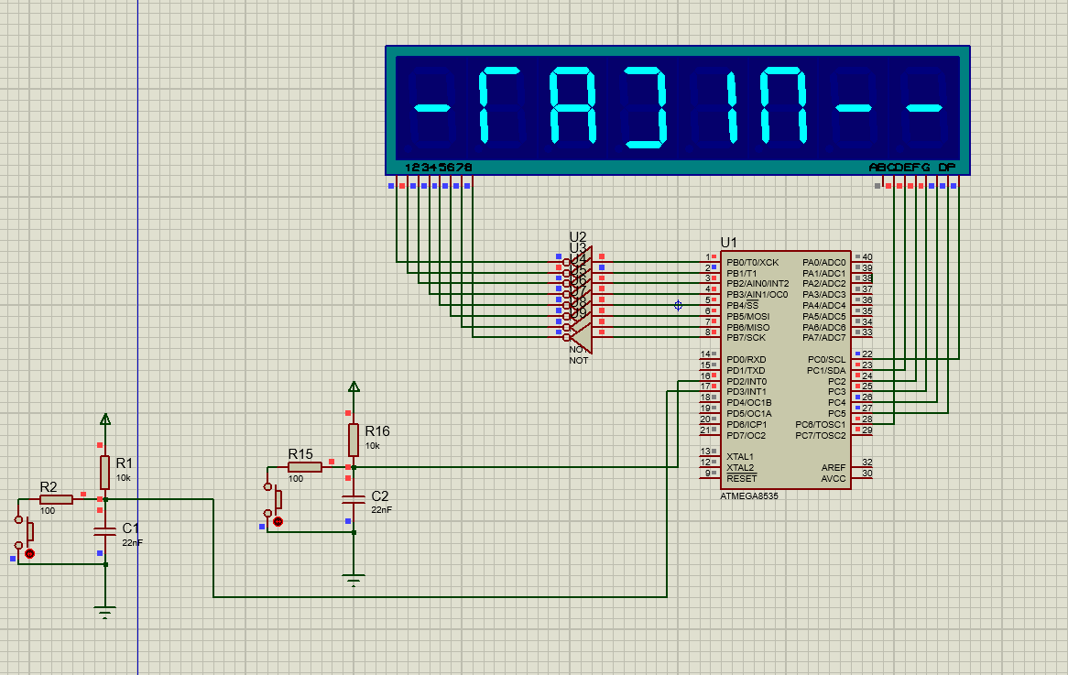

Program menampilkan huruf belajar
.INCLUDE"M8535DEF.INC"
.ORG 0 RJMP MAIN
; BCD UP-DOWN COUNTER MODULO 36, DENGAN 74LS47
; DELAY MENGGUNAKAN LOOP 3 REGISTER
; IMPLEMENTASI: PROTEUS DEC_COUNT_01 [DI PROTEUS_PROJECT]

MAIN:LDI R16,LOW(RAMEND)
OUT SPL,R16
LDI R16,HIGH(RAMEND) OUT SPH,R16

LDI R20,0
OUT DDRA,R20 ; PORT A SBG INPUT LDI R20,0XFF
OUT DDRB,R20 ; PORT B SBG OUTPUT LDI R21,0X99 ; KOMPLEMEN 10 DARI 1
ITU: LDI R18,0 ; INPUT AWAL UP COUNTER SANA: OUT PORTB,R18
RCALL DELAY
IN R17,PINA ; MEMBACA DATA DARI PIN A MOV R16,R17
ANDI R16,1 CPI R16,0
BRNE DOWN ; JUMP KE DOWN COUNTER JIKA R16 = 1 UP: LDI R20,1
MOV R19,R18 ADD R19,R20 RCALL DAA MOV R18,R19
CPI R18,0X36; BATAS ATAS UP COUNTER BRNE SANA
RJMP ITU

INI: LDI R18,0X35 ; NILAI AWAL DOWN COUNTER DOWN:
SINI: OUT PORTB,R18
RCALL DELAY
IN R17,PINA ; MEMBACA DATA DARI PIN A MOV R16,R17
ANDI R16,1 CPI R16,1
BRNE UP ; JUMP KE UP COUNTER JIKA R16 = 0 MOV R19,R18
ADD R19,R21 RCALL DAA MOV R18,R19
CPI R18,0x99 ; BATAS BAWAH DOWN COUNTER BRNE SINI
RJMP INI

DELAY: LDI R23,3 LUP1: LDI R24,0XFF LUP2: LDI R25,0
LUP3: DEC R25
BRNE LUP3 DEC R24 BRNE LUP2

DEC R23 BRNE LUP1 RET
daa: push r16;amankan isi reg. ke stack
push r17 push r21 push r24
in r16,sreg; amankan sreg in r17,sreg
ldi r24,0 ; r24 hanya sbg status dr carry flag adc r24,r24; status carry flag sebelum koreksi
; ambil, amankan kembali sreg, uji half carry
out sreg,r17
brhc lup4; lompat ke lup4 jika H=0 rcall fk_ln; satuan + 06 jika H=1
; rjmp lup5 lup4: mov r21,r19
andi r21,$0f; ambil dgt.satuan cpi r21,$0a ; > 9
brcs lup5; lompat ke lup5 jika < 9 rcall fk_ln; satuan + 06 jika > 9
lup5: out sreg,r17; ambil, amankan kembali sreg, uji carry brcc lup6; lompat ke lup6 jika C=0
rcall fk_hn; puluhan + 60 jika C=1
; rjmp lup7 lup6: mov r21,r19
andi r21,0xf0; ambil dgt.puluhan cpi r21,0xa0
brcs lup7; lompat ke lup7 jika pul < a rcall fk_hn; pul + 60 jika > 9
lup7: out sreg,r16; mengatur carry flag sblm keluar: clc; C = 0
in r16,sreg ;amankan sreg stlh c=0 cpi r24,0 ;menguji status
breq lup8
out sreg,r16;ambil sreg, set c sec; C = 1
in r16,sreg; amankan sreg stlh c=1

lup8:

out sreg,r16;status akhir
pop r24;kembalikan isi reg. dr stack pop r21
pop r17 pop r16 ret

fk_ln: ldi r21,06; koreksi dgt.satuan
out sreg,r16 add r19,r21 in r16,sreg brcc tuh
ldi r21,0x01 add r17,r21

tuh: out sreg,r16
adc r24,r24 ret
fk_hn: ldi r21,$60; koreksi dgt.puluhan
out sreg,r16 add r19,r21 in r16,sreg
adc r24,r24; amankan carry pd r24 ret ; akhir dari prog. subrutin.

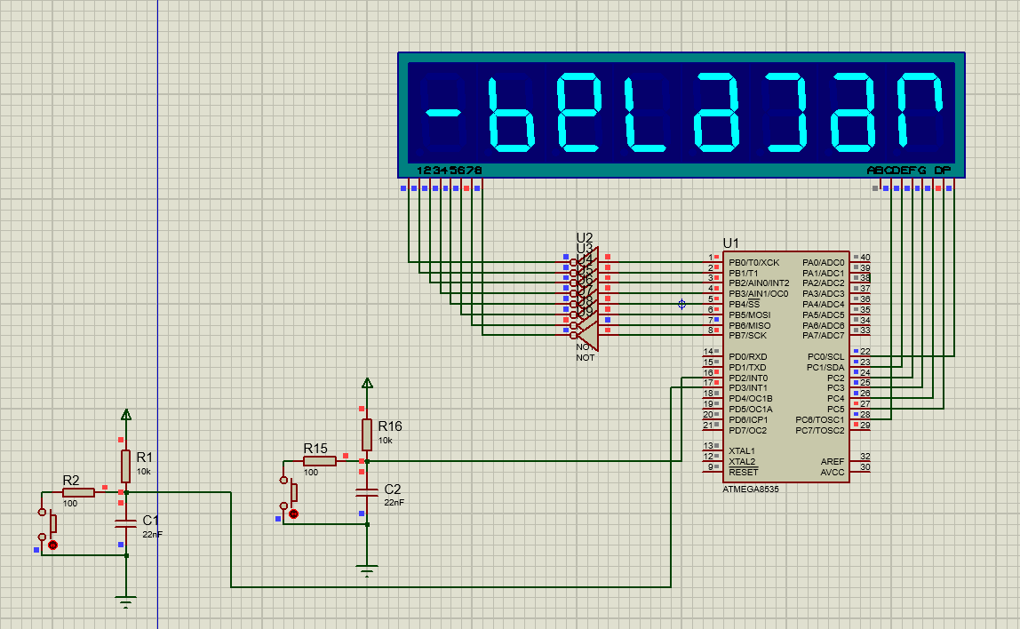

Buat program untuk menampilkan huruf A pada unit peraga 7 Segmen common Anoda, jika tombol int 0 ditekan akan menyebabkan : tampil a kecil selama 2 detik saja, pake push button untuk mengaktifkan int0.
.INCLUDE"M8535DEF.INC"
.ORG 0 RJMP MAIN
.ORG 1 RJMP INT_0

MAIN:LDI R16,LOW(RAMEND)
OUT SPL,R16
LDI R16,HIGH(RAMEND) OUT SPH,R16

LDI R17,0XFF
OUT DDRA,R17 ; PORT B SEBAGAI OUTPUT
LDI R18,8
OUT PORTA,R18
; A KAPITAL PADA 7 SEGMENT CA
AKHIR: RJMP AKHIR

DELAY:
CLI
LDI R23,3
LUP1: LDI R24,0XFF LUP2: LDI R25,0 LUP3: DEC R25
BRNE LUP3 DEC R24 BRNE LUP2 DEC R23 BRNE LUP1 SEI
RET
INT_0:CLI
LDI R19,0X40 OUT GICR,R19 LDI R20,3
OUT MCUCR,R20
; GICR HANYA MENGENABLE INT0

; INT0 AKTIF SAAT RISING EDGE
LDI R26,0X20 OUT PORTA,R26 RCALL DELAY RCALL DELAY
; A KECIL PADA 7 SEGMENT CA
SEI RETI

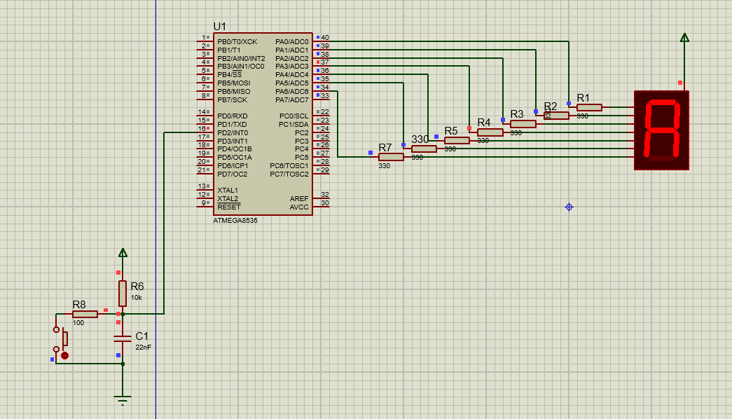

Soal
- Rancang suatu up counter heksadesimal 1 digit modulo 16 menghitung ( 0 – F ) secara berulang, gunakan 7 segment common katoda. Kenaikan nilai counter dikendalikan melalui tombol interrupt 0 (sebagai increment).

Cara menyelesaikan :
Kata kunci
Up counter hexadecimal 1 digit ( 0-F) menggunakan push button.
7 segment common katoda terhubung ke ground, dan diberi logic 1 untuk ON, logic 0 untuk OFF, menggunakan PORT A

POLA 7 SEGMENT

0 3F
1
2
3
4
5
6
7 07
8
9

Tugas Program Utama lakukan inisialisasi : STACK, GICR = 0X40, MCUCR = 2 juga bertugas untuk menentukan isi counter
*counter harus di inisialisasi,
Tugas Program Interrupt Naikkan counter 0 – F
SEI Setelah proses inisialisasi beres

- Kode Program
.INCLUDE"M8535DEF.INC"
.ORG 0
RJMP MAIN

.ORG 1
RJMP INT_0

MAIN: LDI R16,LOW(RAMEND)
OUT SPL,R16
LDI R16,HIGH(RAMEND)
OUT SPH,R16

CLI
LDI R19,0X40
OUT GICR,R19 ; REGISTER GICR HANYA MENGENABLE INT0
LDI R20,2
OUT MCUCR,R20 ; INT0 AKTIF SAAT FALLING EDGE (sisi turun)
SEI

LDI R17,0XFF
OUT DDRA,R17 ; PORT B SEBAGAI OUTPUT

ldi zl,low(2*HEX) ; POINTER Z menunjuk ke HEX KARAKTER
ldi zh,high(2*HEX)
LD R26,Z+
OUT PORTA,R18

DELAY: CLI
LDI R23,3
LUP1: LDI R24,0XFF
LUP2: LDI R25,0
LUP3: DEC R25
BRNE LUP3
DEC R24
BRNE LUP2
DEC R23
BRNE LUP1
SEI
RET

INT_0: CLI

OUT PORTA,R26
RCALL DELAY
RCALL DELAY
SEI
RETI

HEX:
.db 0X3F
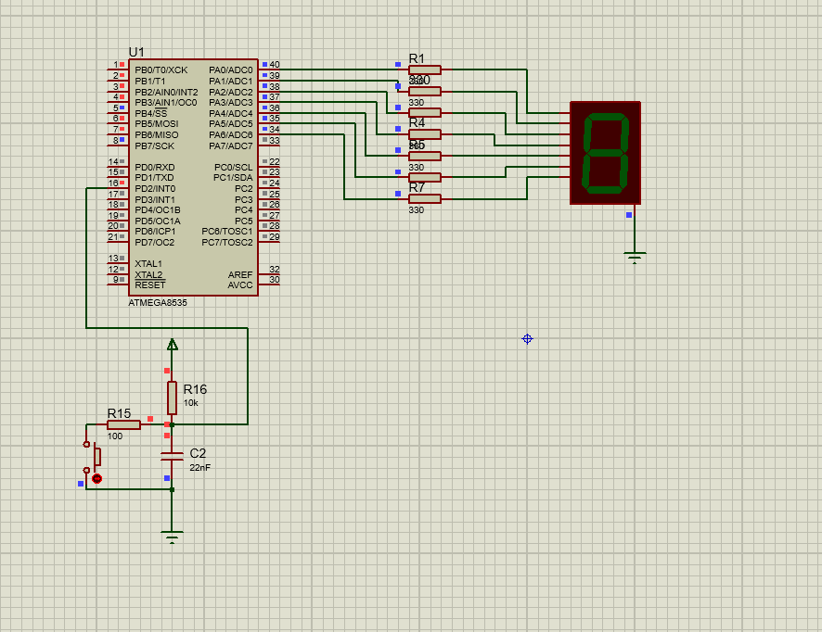
- Rancang suatu DOWN counter heksadesimal 1 digit modulo 16 menghitung ( 0 – F ) secara berulang, gunakan 7 segment common katoda. Kenaikan nilai counter dikendalikan melalui tombol interrupt 0 (sebagai increment).
.include "m8535def.inc"
.org 0
RJMP MAIN

.ORG 0X01 RJMP INT_0

.ORG 0X02 RJMP INT_1
;Rancang suatu Up/Down Counter Heksadesimal 1 digit Modulo 16 (Menghitung naik/turun
;secara berulang dengan range output dari 0 sampai F). Gunakan seven segment jenis
;Common Cathode dengan tombol interupsi INT0 yang berfungsi untuk menaikkan/menurunkan
;nilai counter (Counter incrementer/decrementer); dan INT1 yang berfungsi sebagai
;pengatur Mode kerja Counter (up/down).

MAIN:CLI

LDI R16,LOW(RAMEND) OUT SPL,R16
LDI R16,HIGH(RAMEND) OUT SPH,R16

LDI R20,0XFF OUT DDRA,R20

LDI R20,0XC0 OUT GICR,R20

LDI R20,0X0F OUT MCUCR,R20

LDI R30,LOW(2*POLA) ; INIT POINTER Z LDI R31,HIGH(2*POLA)
LDI R22,0 ; INIT COUNTER SEI

KK: MOV R30,R22 ;MENAMPILKAN ISI COUNTER LPM R2,Z
OUT PORTA,R2 RCALL DELAY RJMP KK

DELAY: CLI
LDI R23,1 LP1: LDI R24,4
LP2: LDI R25,0 LP3: DEC R25
BRNE LP3 DEC R24 BRNE LP2 DEC R23 BRNE LP1 SEI
RET
;=================

INT_0:CLI

MOV R27,R20 ANDI R27,1 CPI R27,1 BRNE TRN INC R22
CPI R22,0X10 BRNE LK1 LDI R22,0 RJMP LK1
TRN: DEC R22
CPI R22,0XFF BRNE LK1 LDI R22,0X0F

LK1:; SEI
RETI

INT_1:CLI
INC R20 SEI RETI
;==================
.ORG 0X80 POLA:
.DB 0X3F,0X06,0X5B,0X4F,0X66,0X6D,0X7D,0X07
.DB 0X7F,0X6F,0X77,0X7C,0X39,0X5E,0X79,0X71

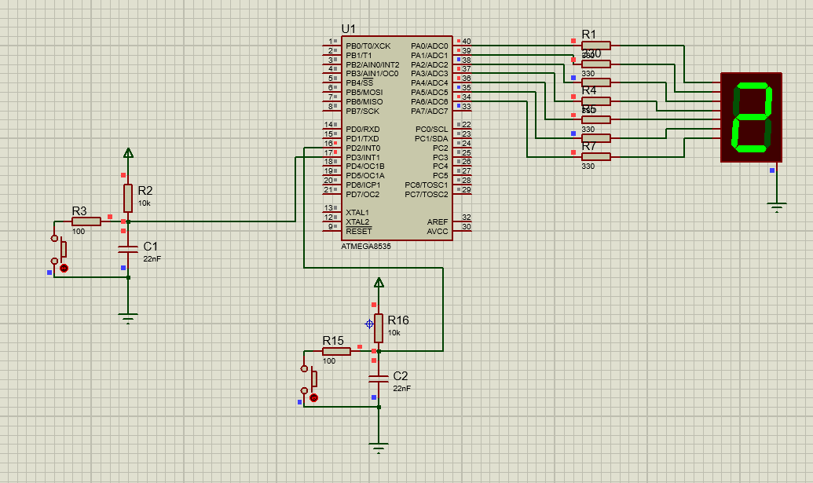
- Rancang suatu UPDOWN counter heksadesimal 1 digit modulo 16 menghitung ( 0 – F ) secara berulang, gunakan 7 segment common katoda. Kenaikan nilai counter dikendalikan melalui tombol interrupt 0 (sebagai increment).
INT 1 = GANTI MODE
INT 0 = MODE KERJA

- Kode Program
.include "m8535def.inc"
.org 0
RJMP MAIN

.ORG 0X01
RJMP INT_0

.ORG 0X02
RJMP INT_1
; Up-Counter Heksadesimal Modulo 16 (Menghitung secara berulang
; dari 0 sampai F); INT0 berfungsi sebagai Counter Incrementer
; Menggunakan Seven Segment Common Cathode.
; PROTEUS PROJECT: UP-CNT-INT0

MAIN: CLI
LDI R20,LOW(RAMEND)
OUT SPL,R20
LDI R20,HIGH(RAMEND)
OUT SPH,R20
LDI R20,0XFF
OUT DDRA,R20
LDI R20,0XC0
OUT GICR,R20
LDI R20,0X0F
OUT MCUCR,R20
LDI R30,LOW(2*POLA) ; INIT POINTER Z
LDI R31,HIGH(2*POLA)
LDI R22,0 ; INIT COUNTER
SEI
KK: MOV R30,R22
LPM R2,Z
OUT PORTA,R2
RCALL DELAY
RJMP KK

DELAY: CLI
LDI R23,1
LP1: LDI R24,4
LP2: LDI R25,0
LP3: DEC R25
BRNE LP3
DEC R24
BRNE LP2
DEC R23
BRNE LP1
SEI
RET
;=================
INT_0: CLI
MOV R21,R20
ANDI R21,1
CPI R21,1
BRNE TRN
INC R22
CPI R22,0X10
BRNE LK1
LDI R22,0
RJMP LK1
TRN: DEC R22
CPI R22,0XFF
BRNE LK1
LDI R22,0X0F
LK1: SEI
RETI

INT_1: CLI
INC R20
SEI
RETI
;==================
.ORG 0X80
POLA:
.DB 0X3F,0X06,0X5B,0X4F,0X66,0X6D,0X7D,0X07
.DB 0X7F,0X6F,0X77,0X7C,0X39,0X5E,0X79,0X71

- Hasil Program
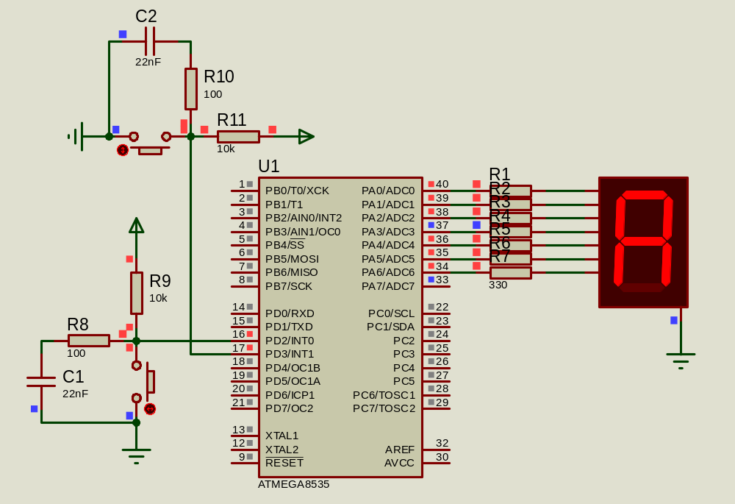

- Rancang suatu Up Counter Heksadesimal 2 digit Modulo 45 (Menghitung naik secara berulang dari 00 sampai 2C). Gunakan seven segment jenis Common Anode dengan tombol interupsi INT2 yang berfungsi untuk menaikkan nilai counter (Counter incrementer).

- Kode Program
.include "m8535def.inc"
.org 0
RJMP MAIN

.ORG 0X012
RJMP INT_2
; Up-Counter Heksadesimal Modulo 45 (Menghitung secara berulang
; dari 0 sampai 2C); INT0 berfungsi sebagai Counter Incrementer
; Menggunakan Seven Segment Common Cathode.
; PROTEUS PROJECT: UP-CNT-INT0
;

MAIN: CLI
LDI R20,LOW(RAMEND)
OUT SPL,R20
LDI R20,HIGH(RAMEND)
OUT SPH,R20
LDI R20,0XFF
OUT DDRA,R20
OUT DDRC,R20
LDI R20,0X20
OUT GICR,R20
LDI R20,0X40
OUT MCUCSR,R20
LDI R30,LOW(2*POLA) ; INIT POINTER Z
LDI R31,HIGH(2*POLA)
LDI R22,0 ; INIT COUNTER
SEI
KK: MOV R27,R22
ANDI R27,0XF0 ; MENGAMBIL ENAMBELASAN
LSR R27
LSR R27
LSR R27
LSR R27
MOV R30,R27
LPM R2,Z
OUT PORTA,R2
MOV R27,R22
ANDI R27,0X0F ; MENGAMBIL SATUAN
MOV R30,R27
LPM R2,Z
OUT PORTC,R2
RCALL DELAY
RJMP KK

DELAY: CLI
LDI R23,1
LP1: LDI R24,4
LP2: LDI R25,0
LP3: DEC R25
BRNE LP3
DEC R24
BRNE LP2
DEC R23
BRNE LP1
SEI
RET
;=================
INT_2: CLI
INC R22
CPI R22,0X2D
BRNE LK1
LDI R22,0
LK1: SEI
RETI
;==================
.ORG 0X80
POLA:
.DB 0XC0,0XF9,0XA4,0XB0,0X99,0X92,0X82,0XF8
.DB 0X80,0X90,0X88,0X83,0XC6,0XA1,0X86,0X8E

- Hasil Program
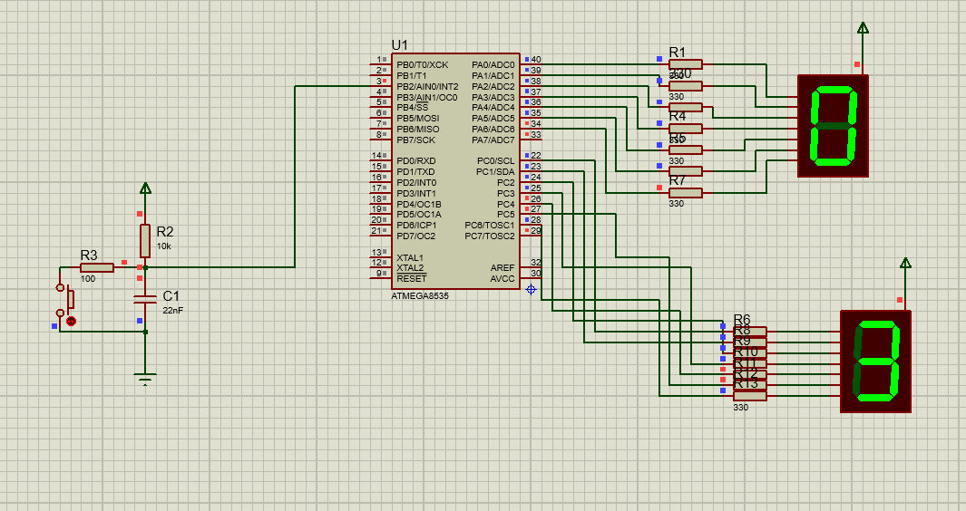

- Seperti soal nomor 4, tapi untuk Down Counter.
- Kode Program
.include "m8535def.inc"
.org 0
RJMP MAIN

.ORG 0X012
RJMP INT_2
; Up-Counter Heksadesimal Modulo 45 (Menghitung secara berulang
; dari 0 sampai 2C); INT0 berfungsi sebagai Counter Incrementer
; Menggunakan Seven Segment Common Cathode.
; PROTEUS PROJECT: UP-CNT-INT0
;

MAIN: CLI
LDI R20,LOW(RAMEND)
OUT SPL,R20
LDI R20,HIGH(RAMEND)
OUT SPH,R20
LDI R20,0XFF
OUT DDRA,R20
OUT DDRC,R20
LDI R20,0X20
OUT GICR,R20
LDI R20,0X40
OUT MCUCSR,R20
LDI R30,LOW(2*POLA) ; INIT POINTER Z
LDI R31,HIGH(2*POLA)
LDI R22,0X2C ; INIT COUNTER
SEI
KK: MOV R27,R22
ANDI R27,0XF0 ; MENGAMBIL ENAMBELASAN
LSR R27
LSR R27
LSR R27
LSR R27
MOV R30,R27
LPM R2,Z
OUT PORTA,R2
MOV R27,R22
ANDI R27,0X0F ; MENGAMBIL SATUAN
MOV R30,R27
LPM R2,Z
OUT PORTC,R2
RCALL DELAY
RJMP KK

DELAY: CLI
LDI R23,1
LP1: LDI R24,4
LP2: LDI R25,0
LP3: DEC R25
BRNE LP3
DEC R24
BRNE LP2
DEC R23
BRNE LP1
SEI
RET
;=================
INT_2: CLI
DEC R22
CPI R22,0XFF
BRNE LK1
LDI R22,0X2C
LK1: SEI
RETI
;==================
.ORG 0X80
POLA:
.DB 0XC0,0XF9,0XA4,0XB0,0X99,0X92,0X82,0XF8
.DB 0X80,0X90,0X88,0X83,0XC6,0XA1,0X86,0X8E

- Hasil Program
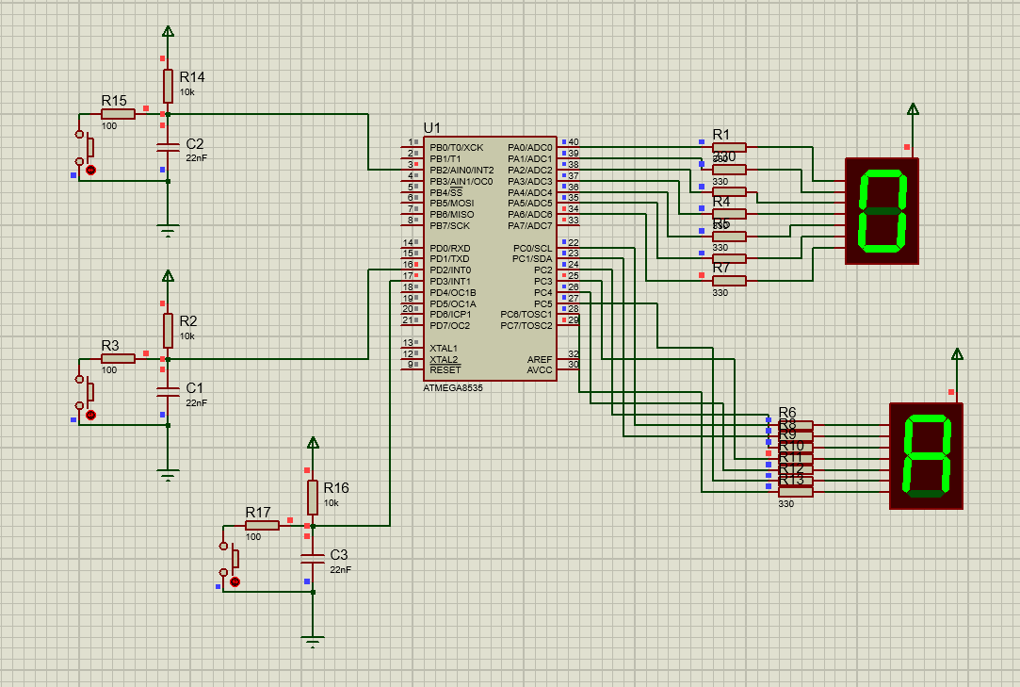
- Up/Down-Counter Heksadesimal Modulo 21 dan 35 (Menghitung secara berulang dari 0 sampai F); INT0 berfungsi sebagai Counter Incrementer Menggunakan Seven Segment Common Cathode. INT1 mengubah modulo. INT2 mode kerja counter
- Kode Program
include "m8535def.inc"
.org 0
RJMP MAIN

.ORG 0X001
RJMP INT_0

.ORG 0X002
RJMP INT_1

.ORG 0X012
RJMP INT_2
; Up/Down-Counter Heksadesimal Modulo 21 dan 35
; INT0 berfungsi sebagai Counter Incrementer
; Menggunakan Seven Segment Common Anode INT1 mengubah modulo. INT2 mode kerja counter
; PROTEUS PROJECT: UP-CNT-INT0

MAIN: CLI
LDI R20,LOW(RAMEND)
OUT SPL,R20
LDI R20,HIGH(RAMEND)
OUT SPH,R20
LDI R20,0XFF
OUT DDRA,R20
OUT DDRC,R20
LDI R20,0XE0
OUT GICR,R20
LDI R20,0X0F
OUT MCUCR,R20
LDI R20,0X40
OUT MCUCSR,R20
LDI R30,LOW(2*POLA) ; INIT POINTER Z
LDI R31,HIGH(2*POLA)
LDI R22,0 ; INIT COUNTER
SEI
KK: MOV R27,R22
ANDI R27,0XF0 ; MENGAMBIL ENAMBELASAN
LSR R27
LSR R27
LSR R27
LSR R27
MOV R30,R27
LPM R2,Z
OUT PORTA,R2
MOV R27,R22
ANDI R27,0X0F ; MENGAMBIL SATUAN
MOV R30,R27
LPM R2,Z
OUT PORTC,R2
RCALL DELAY
RJMP KK

DELAY: CLI
LDI R23,1
LP1: LDI R24,4
LP2: LDI R25,0
LP3: DEC R25
BRNE LP3
DEC R24
BRNE LP2
DEC R23
BRNE LP1
SEI
RET
;=================
INT_0: CLI
MOV R21,R17
ANDI R21,1
BRNE TRN
MOV R19,R18
ANDI R19,1
BRNE MOD35H
INC R22
CPI R22,0X15
BRLT LK1
LDI R22,0
RJMP LK1
MOD35H: INC R22
CPI R22,0X23
BRNE LK1
LDI R22,0
RJMP LK1
TRN: MOV R19,R18
ANDI R19,1
BRNE MD35H
DEC R22
CPI R22,0XFF
BRNE LK1
LDI R22,0X14
RJMP LK1
MD35H: DEC R22
CPI R22,0XFF
BRNE LK1
LDI R22,0X22
LK1: SEI
RETI

INT_1: CLI
INC R18
SEI
RETI

INT_2: CLI
INC R17
SEI
RETI
;==================
.ORG 0X80
POLA:
.DB 0XC0,0XF9,0XA4,0XB0,0X99,0X92,0X82,0XF8
.DB 0X80,0X90,0X88,0X83,0XC6,0XA1,0X86,0X8E

